DELTONA, Fla. — The hardest thing isn’t the voice. It isn’t the makeup or spray-on gray hair. It’s the confidence. To move and talk with an attitude some have called arrogant, even cocky. To hold yourself as the most powerful man in the world. It feels completely unnatural to Sean Banks but when he gets it just right, people come running.
They fawn over him, curse him out, confess to him their innermost fears. They tell him America is crumbling around them and how he could fix it if only he’d do this one thing. “The smile is where I’m closest — the mouth, the
cheekbones. I got the ears too.” To be a presidential impersonator in the age of Obama is about as fraught as climbing onto the roof in a lightning storm and holding up a 9-iron.
"You get called all the horrible names people are afraid to say to him in public,” Banks said. “But you see the love too, the almost reverence people have.”
Witnessing Obama’s effect on others has changed how Banks sees America and himself. A middle school teacher in Florida who moonlights as a Faux-bama, Banks, 47, has been so moved that he’s tried running, unsuccessfully, for a local city council seat. It’s made him want to fix the things people are always begging his Obama to fix — to become part of the hope discussed so long ago in the early days of Obama, when Banks would get mobbed just walking down the street.
The Obama Effect:
The job has gotten much tougher the past two years, he said on a recent Sunday afternoon while getting into character for a local parade.
His gigs have taken him uncomfortably deep into Republican territory, where clients mostly want a Barack to heckle and hate. As he stenciled Obama’s trademark mole on his cheek, Banks said he’s seen how casually someone will hurl the N-word at a complete stranger. At a Fort Lauderdale event, one man leaned in close and said, “If I had a gun, I’d shoot you.”
In front of a bathroom mirror, Banks dabbed on purplish brown lipstick, checking the coloring against a small photo of Obama. In the dining room, his wife, Judy, stapled hundreds of Jolly Ranchers onto impersonator-for-hire business cards to hand out along the parade route, their latest ploy for new business.
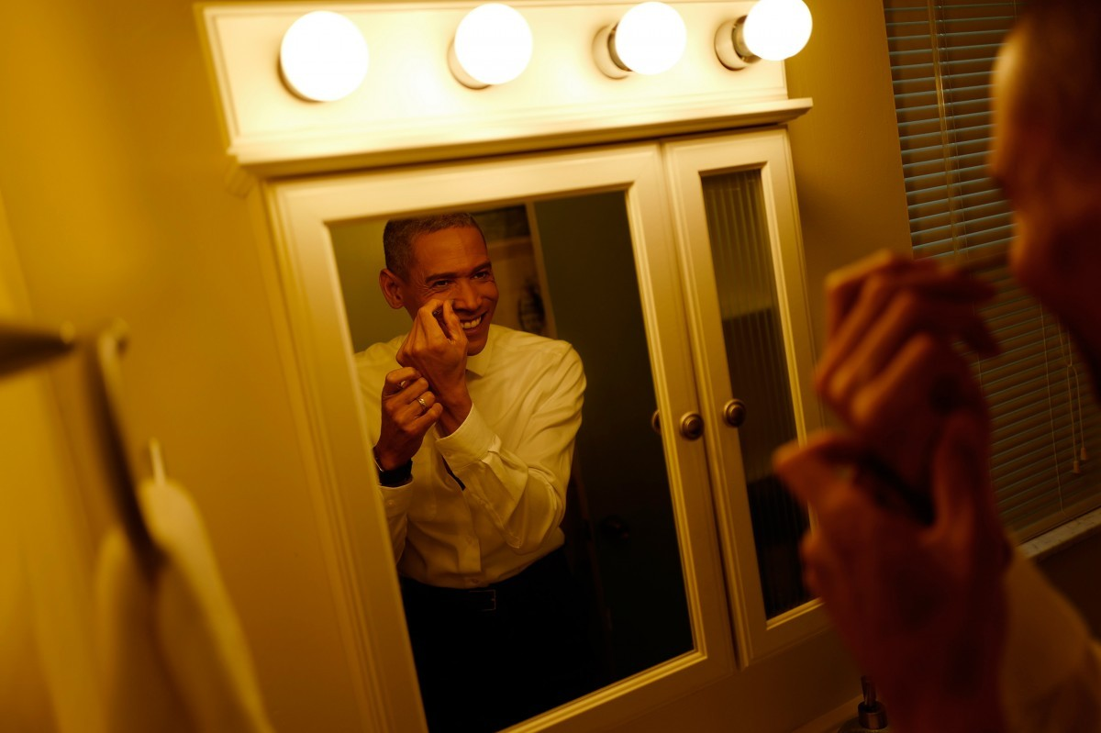Sean Banks gets into character before participating in a parade in his hometown of Deltona, Fla. Here, he applies the final touches of makeup, which includes the mole he nearly forgot before leaving for the parade. (Charles Ommanney / The Washington Post)
Advice that hits home most, Banks said, came from a longtime Bill Clinton in Chicago. Spend these last remaining months figuring out what exactly makes your guy special, the Chicago Clinton told him. Only by focusing on that, can you build an Obama that will last.
Expectations of (fake) leaders
What we want from our presidential impersonators says a lot about what we want from our presidents. We want photographic proof we were once this close to the pinnacle of power. We want them to know who we are and to know who they really are behind that facade of politics.
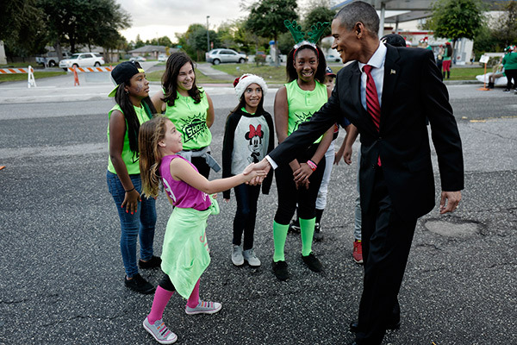View Photos
And when it comes to Obama, his impersonators say, what we want is even more complicated — by issues of race, by our ever deepening political divisions, by all the messy things we are still working out as a country and often superimpose onto him.
“You get called all the horrible names people are afraid to say to him in public. But you see the love too, the almost
reverence people have.”
—Sean Banks, Obama Impersonator

We want an Obama who lives up to our expectations. We want an Obama — amid the constant talk of historic first black this or that — who seems human, fallible. We want him to prove true the stereotypes we secretly harbor, and at the same time for him to mock and poke holes at those beliefs.
But often what we want most, it turns out — even for many who despise him — is simply to encounter him, face to face.
Dawn of the Obamamen
In the fall of 2008, while Obama was still fighting for the Oval Office, another battle raged on the sidelines over who would become his top doppelganger. Look-a-likes were coming of the woodwork, talent agents said, with patchy results. There were chubby Obamas, overly hairy Obamas, Obamas with big ears and little else to offer. Obama’s ascent from Illinois state senator to White House candidate was so quick and improbable, his impersonators say, that the country back then in many ways was still getting to know him. Among the early contenders, Sean Banks had an advantage. With parents who combined a good dose of Chinese with Spanish, Indian and Welsh, Banks somehow ended up with a face surprisingly similar to Obama’s.

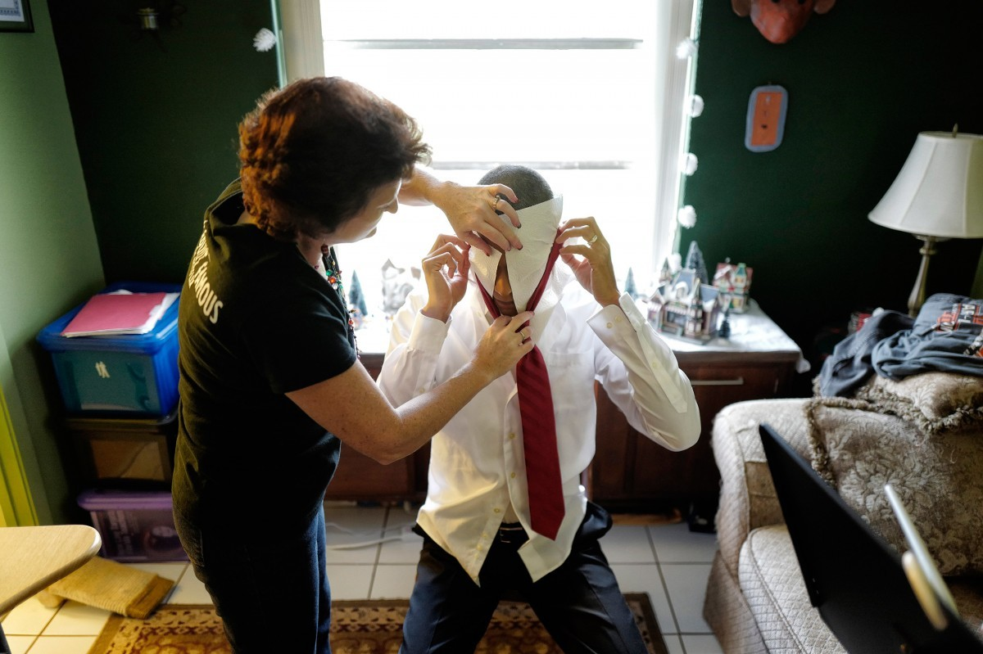Obama impersonator Sean Banks gets help from his wife, Judy, putting on his makeup before an event. (Charles Ommanney / The Washington Post)

How to mock a president:
The problem was one of propriety, said Peter Robinson, a historian at the College of Mount St. Joseph. “People worried, ‘Will the president take offense? Will the public take offense?”
It wasn’t until the glamorous Camelot days of John F. Kennedy that the idea finally took root. Vaughn Meader, a little-known performer with a dead-on Boston accent, produced a comedy album, “The First Family,” which became the fastest, best-selling album would be great to have an audio clip here from that album ever at the time. It won Album of the Year at the Grammys and was memorized by every wiseass ok? in the country.
Then came Kennedy’s assassination, and for a long time, no one had the stomach to laugh at the presidency.
. . . Until Richard Nixon.
“Once you hit Watergate, Vietnam, all that worry about propriety goes out the window,” Robinson said. “Suddenly, the comedian is the one speaking truth, the one with authority.”
From there, an entire industry blossomed. Obama’s election in 2008, however, presented new problems.
“No one could get a bead on what to do with him,” said Greg Thompson, a Florida agent who manages hundreds of impersonators. “That first year, most jobs were strictly meet-and-greets or photo ops . . . no speeches or real acts.”
Race was a big factor. Given the country’s fraught racial history, mocking the first black man to reach the highest office seemed riddled with land mines.
Even Saturday Night Live, the most prestigious stage for presidential impersonations, struggled to make Obama funny, first tapping cast member Fred Armisen, only to go back to the drawing board four years later with Jay Pharoah.It is telling, comedians say, that the most widely acclaimed take on Obama — by Comedy Central’s Key and Peele — took two people to pull off splitting Obama into dueling personalities that played off each other as much as him for laughs.

What makes Obama Obama?
“The smile is where I’m closest — the mouth, the cheekbones. I got the ears too,” he said. He discovered the resemblance at a politically themed Key West costume festival the weekend before the 2008 election. Putting on a suit and tie for the first time in years, he couldn’t walk 10 feet without someone tugging at him, trying to snap a picture.
But looks only got him so far. Banks began hunting for his inner Obama.
He scoured the Internet, scrutinizing Obama’s choice of words, his early life and mannerisms.
On the afternoon before the parade, sitting at a dining table now covered in Jolly Ranchers and business cards, Banks tried to summarize the thousands of hours he has spent on his quest.
Banks pulled out his laptop and started typing the word “Obama.” Before he could finish, his web search history kicked out a list a mile long: “Obama walking,” “Obama shaking hands,” “Obama sings uptown funk,” etc.
What Banks discovered was an entire spectrum of Obamas to emulate: The classic 2008 Hope-and-Change Obama; light-hearted Correspondents’ Dinner Obama; angry, Post-Mass Shooting Obama; State Dinner Obama.; Casual Obama.
For Banks, the one that finally helped him uncover the man’s essence was Election Night Obama.
On his laptop, he typed “Grant Park.” Up popped videos from the Chicago, November 2008. In them, you can see Oprah crying; Jesse Jackson too.
Banks pressed mute. “It’s easier to see it without the sound,” he said.
Notice, Banks said, how Obama pauses, how he purses his lips as if to convey, ‘I’ve got something so good to tell you.’ Then, just before Obama launched into his speech, as he opened his mouth, Banks hit pause.
“See how he tilts his head? How he lifts his chin up at the audience? That’s the cockiness. That’s him saying, ‘Don’t worry. I’m in charge here. I got this. I got this.’ ”

In search of an identity
It is a confidence that Banks has never felt in his own life.
He spent so much of it meandering — from New Jersey to Florida, studying graphic design, managing a KFC, taking photographs for tourists at Disney World against their choice of fantasy backdrops.
One job he liked — training new hires at Disney — led him to get a master’s degree in education. That led to his current job teaching reading to sixth and eighth graders.
Meaningful work, he said, but it never felt quite right.
Rebelling against this new identity as a staid, boring teacher, he bought a Harley-Davidson and started commuting to school in a black leather jacket and skull necklace. He always thought there would be more to life, more to him.
By contrast, the Obama that Banks glimpsed in the Grant Park speech was a man entirely at ease with who he was and what lay before him.
Chasing that confidence, Banks went to a voice coach in Orlando. Picture yourself as a rare, magnificent creature, she told him. Now speak with that attitude, like you’re an entirely unique beast.
“Don’t worry about timing. If you need a moment, you take that moment. You’re the leader of the free world. They can all wait on you.” —Sean NgYing's acting coach
He took lessons from an acting coach. “Don’t worry about timing,” the coach told him. “If you need a moment, you take that moment. You’re the leader of the free world. They can all wait on you.”
Finally, after seven years, Banks no longer struggles nowadays to summon Obama.
There are times when it even clings to him like a filmy residue. Some days, after a gig, he’ll go out in jeans and biker jacket, and — even without the voice, suit or makeup — people come running.
He has helped a Vietnamese family celebrate their patriarch’s 60th birthday. He’s sung Yiddish songs at a Jewish boys camp in New Jersey. He’s performed in front of a nude audience at a swinger’s club.
He bills himself as “Sean Banks” on business cards, choosing a racially ambiguous last name after watching critics pummel SNL’s Armisen because he was mixed race, like Banks, and not black like Armisen’s replacement.
Perhaps as a result, Banks has gotten a lot of jobs from African American families — birthdays, family reunions, anniversaries — and found himself moved by the reverence with which they treat Obama. At one family reunion in South Carolina, Banks said, the crowd stood up immediately when he walked in the room. “I had to keep telling them, ‘Please have a seat,’ ” he said.
For someone who grew up considering himself Asian American, it has been eye-opening to see how other races behave among themselves. How they often put on a protective shield for the outside world and how open and familiar they are with each other.
At times, Banks said, the Obama suit feels like a superpower letting him see people as they really are.

Hope and changed
On the day of the Deltona parade, a crowd began forming almost as soon as Banks pulled up on his Harley.
“I waited in line eight hours to vote for you,” one man shouted. “I voted for you twice!” said another. A young mother was out of breath from chasing him across the parking lot.An elderly woman took his arm with a hard look, saying, “I’m praying for you, Mr. President.”
She explained later that she had voted against Obama, objected to everything he stood for, but wanted him to know she asked the Lord every day to guide him. Also, she said, she wanted a selfie.
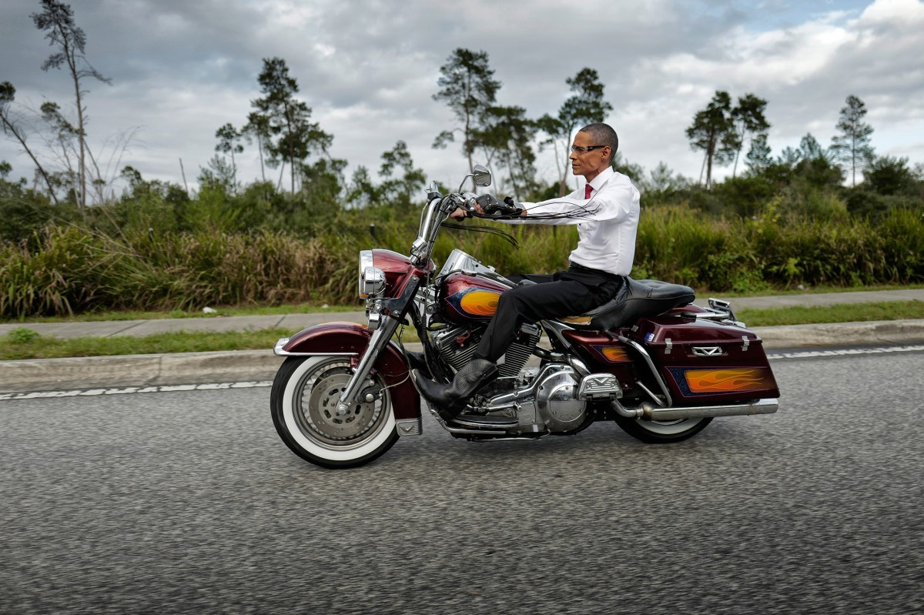Banks rides to work and to local events on his Harley-Davidson motorcycle. He says people often wave and stare out their car windows as he passes. (Charles Ommanney / The Washington Post)
Before Obama, Banks wasn’t interested in politics. For years, he considered himself an independent, then a Hillary supporter. His wife, Judy, a high school chemistry teacher, was always the politically active one.
But being Obama changed something inside him.
In 2012, Banks accepted a position as president of the local Democratic club. Soon after, he ran for a city commissioner seat. “I thought I could help,” he said. “We’re not a rich community. You look around and you don’t see mansions or fancy cars. You see Dollar Stores and struggling working-class families.”
The campaign lasted only a few months. Banks said he dropped out because someone close to him needed his help.
Looking back, Banks said he feels he dodged a bullet.
He recalled one day when he was flying to an Obama gig and looked out his window to see the sprawling country below. It made him think about how strange it was that he resembled the man responsible for this land. And suddenly for a moment, he said, he felt the crushing weight of an entire country on him. It was scary, disorienting.
“When you become a leader,” he realized, “you sign your whole life away.”

The last of the Obamamen:
Only a handful now remain from the initial flood of Obamamen in 2008.
And he is quite possibly the most earnest Obama.
He never disparages the president and diligently avoids putting things into the president’s mouth that aren’t true. When a company asked him to wear a pink dress as Obama in return for a cut of sales — a job that he believes could have netted as much as $20,000 — he turned them down.
He wants to parody the president, he said, not lie about him.
He tries to make people feel the way Obama would. When they try to tell him their life story, he listens. When they ask for help, he lets them down gently with a quip.
He understands why many are drawn to Obama, why some are reluctant to let him go. “Being close to him makes them feel important,” he said. “For just a moment they can put aside the reality of life. They get to be special.”
He understands because he feels it himself.
That night, after the parade, Banks stood in front of his bathroom mirror and began the long process of becoming himself again. He wiped off the Obama lips, the eyebrows. He washed the gray out of his hair.
“It’s hard to go back after being at the center of it all, where people literally play music every time you walk in the room.”
—Sean Banks, Obama Impersonator

Waiting for him at school the next day was a portable classroom with peeling paint. A broken air conditioner. The sarcastic remarks of his eighth graders.
There have been Mondays after gigs when he’s sat on his motorcycle in the school parking lot and just stared at the gas tank, screwing up the will to walk in.
“It’s hard to go back after being at the center of it all, where people literally play music every time you walk in the room,” he said.
And so he refuses to quit.
Most of the other Faux-bamas already have plans to move on in the post-presidency, but Banks can't help believing there’s something special about Obama that will buck the trend of waning interest. He has seen how deep the feeling for him runs in this country, in both directions. He has felt the sense of history surrounding him.
In recent weeks, Banks has begun work on something new — an educational act that takes his audience from the bitter roots of slavery to America’s first black president. He wants to take what is special about Obama and combine it with his own talents as a teacher.
For so long, Banks said, he has pretended to be someone else. And while he may not be Obama, he has come to see that there is some Obama in him yet.
Alice Crites contributed to this report.
/

